CHAPTER FOUR
IMPLEMENTATION
4.1 Introduction
This chapter presents the full implementation of the AI-powered chatbot for university information services. It describes each programming language and tool that was used and explains why it was chosen, presents samples of the key parts of the code, includes screenshots of the working system, and reports the results of functional testing. The chapter follows the same sequence as the system design in Chapter Three, moving from the dataset and machine learning model through to the backend, the frontend, and finally the testing results.
4.2 Programming Languages and Tools Used
4.2.1 Python 3.10
Python was used for all backend development and machine learning work in this project. It was chosen because it is the most widely used language in artificial intelligence and machine learning, it runs on all major operating systems without any changes, and it has a large collection of free, well-documented libraries that cover everything needed in this project. Python handles the intent dataset processing, model training, text vectorisation, and the API that connects the chatbot to the frontend.
4.2.2 Flask 2.x and Flask-CORS
Flask is a lightweight Python web framework that was used to build the backend API of this system. It was chosen because it is simple to set up, easy to understand, and works naturally with Python machine learning libraries without adding unnecessary complexity. Flask-CORS was added alongside it to allow the frontend and backend to communicate with each other even when they are running on different ports during development, which is a standard requirement for modern web applications.
4.2.3 scikit-learn
scikit-learn is a Python library that provides reliable, well-tested machine learning tools. It was used in this project for two main purposes: TF-IDF vectorisation, which converts the user's typed question into a format the model can read, and Multinomial Naive Bayes classification, which predicts which intent category the question belongs to. scikit-learn was chosen because both tools are available within the same library and work together seamlessly, and because it is the standard library used in academic machine learning work.
4.2.4 pickle
pickle is a Python module that saves trained objects to disk so they can be loaded again later without retraining. In this project, pickle was used to save the trained Naive Bayes model and the fitted TF-IDF vectoriser after training. When the Flask application starts up, it loads these saved files from disk rather than retraining from scratch every time, which makes the system start up almost instantly.
4.2.5 Next.js and React
Next.js is a modern web development framework built on top of React that was used to build the chat interface that users see and interact with. It was chosen because it produces fast, responsive web pages that work on both desktop and mobile devices without requiring any software to be installed. React provides the component structure that makes the chat interface easy to build and maintain, while Next.js adds the server-side features that make the application load quickly.
4.2.6 TypeScript
TypeScript was used on the frontend to write more reliable and structured code. It is a version of JavaScript that adds type checking, which means that certain kinds of programming errors are caught before the application runs rather than after. This makes the code easier to maintain and reduces the chance of unexpected errors appearing in the interface.
4.2.7 Tailwind CSS
Tailwind CSS was used to style the entire frontend interface. It was chosen because it allows styling to be applied quickly and consistently using short class names directly in the component code, without needing to write separate style sheets for each element. The result is a clean, professional layout that adjusts automatically to fit different screen sizes on both phones and computers.
4.2.8 JSON
The intent dataset is stored in a JSON file called intents.json. JSON was chosen as the storage format because it is human-readable, easy to edit, and simple for Python to read and write. Any staff member at the university who wants to add a new question and answer pair to the chatbot can do so simply by editing this file, without needing to change any of the code.
4.3 Dataset Implementation
The chatbot's knowledge base is stored in the intents.json file. Each entry in this file represents one topic area and contains three things: a tag, which is a short name for the topic; a list of patterns, which are example questions a user might ask about that topic; and a list of responses, which are the answers the chatbot can give. When the model predicts a topic, one response from the matching list is selected and returned to the user.
The dataset covers the five intent categories that fall within the scope of this study:
- Admission information, covering requirements, application process, and cut-off marks.
- Post-UTME enquiries, covering registration, screening dates, and required documents.
- Courses and programmes, covering available courses, faculties, and departments.
- Accommodation, covering hostel availability, application process, and hostel fees.
- Clearance procedures, covering the steps, required documents, and timelines for departmental and faculty clearance.
Each intent has multiple patterns written in different ways so that the model can recognise the same question even when it is phrased differently. For example, the admission intent includes patterns such as "How do I get admission?", "What are the entry requirements?", and "I want to apply to University of Abuja", all of which map to the same set of responses.
4.3.1 Sample Dataset Structure
The code below shows a simplified example of how one intent entry is structured in the intents.json file.

{
"intents": [
{
"tag": "admission",
"patterns": [
"How can I get admission?",
"What are the admission requirements?",
"How do I apply to University of Abuja?"
],
"responses": [
"To gain admission into the University of Abuja,
you need a minimum of five O-Level credits..."
]
}
]
}

4.4 Machine Learning Model Implementation
4.4.1 Text Vectorisation
Before the machine learning model can read a user's question, the text has to be converted into numbers. This is done using TF-IDF vectorisation. TF-IDF assigns a score to each word based on how often it appears in a specific question and how rarely it appears across all the questions in the dataset. Words that are common across many questions carry less weight, while words that are specific to one topic, such as "fees", "hostel", or "clearance", carry more weight. This makes the model better at telling similar questions apart.
4.4.2 Model Training
The training process loads all the question patterns from the dataset, converts them to TF-IDF vectors, and trains the Multinomial Naive Bayes model on those vectors. Once training is complete, both the trained model and the fitted vectoriser are saved to disk so they do not need to be retrained every time the application starts. The code below shows the core training logic.

import json, pickle
from sklearn.feature_extraction.text import TfidfVectorizer
from sklearn.naive_bayes import MultinomialNB

with open("intents.json") as f:
data = json.load(f)

texts, labels = [], []
for intent in data["intents"]:
for pattern in intent["patterns"]:
texts.append(pattern)
labels.append(intent["tag"])

vectoriser = TfidfVectorizer()
X = vectoriser.fit_transform(texts)
model = MultinomialNB()
model.fit(X, labels)

pickle.dump(model, open("model.pkl", "wb"))
pickle.dump(vectoriser, open("vectoriser.pkl", "wb"))

4.4.3 Prediction and Confidence Threshold
At runtime, when a user sends a message, the saved vectoriser converts it to the same numerical format used during training, and the Naive Bayes model predicts which intent category it belongs to. The model also produces a confidence score showing how certain it is about the prediction. If the confidence score is below a defined threshold, the chatbot returns a fallback response instead of a potentially wrong answer. The code below shows the prediction function.

def predict_intent(message):
vec = vectoriser.transform([message])
proba = model.predict_proba(vec)[0]
confidence = max(proba)
if confidence < 0.3:
return "fallback", confidence
intent_tag = model.predict(vec)[0]
return intent_tag, confidence

4.5 Backend API Implementation
The backend was built using Flask and exposes a single main endpoint that the frontend calls whenever a user sends a message. When a POST request arrives at /chat, the backend validates the request, extracts the message, runs the prediction function, retrieves the matching response from the dataset, and returns the result as a JSON object. The code below shows the core route handler.

from flask import Flask, request, jsonify
from flask_cors import CORS
import random

app = Flask(__name__)
CORS(app)

@app.route("/chat", methods=["POST"])
def chat():
data = request.get_json()
if not data or not data.get("message", "").strip():
return jsonify({"error": "Message cannot be empty"}), 400
message = data["message"].strip()
intent_tag, confidence = predict_intent(message)
if intent_tag == "fallback":
response = "I am not sure I understand. Please try rephrasing."
else:
responses = get_responses(intent_tag)
response = random.choice(responses)
return jsonify({"response": response,
"intent": intent_tag,
"confidence": round(confidence, 2)})

4.6 Frontend Implementation
The frontend chat interface was built using Next.js, React, TypeScript, and Tailwind CSS. It provides the visual interface through which students and staff interact with the chatbot. When a user types a message and presses send, the frontend adds the message to the chat display, sends it to the Flask backend using an HTTP POST request, waits for the response, and then adds the bot's reply to the chat. A typing indicator is shown while the response is being fetched so the user knows the system is working.
The interface includes the following features:
- A university-branded header at the top of the page
- Quick-question buttons that users can tap to ask common questions without typing
- A scrollable chat area showing the conversation history with clearly separated user and bot message bubbles
- A typing indicator that appears while the bot is preparing a response
- A text input field and send button at the bottom
- Automatic scrolling to the latest message after each response
- A layout that works on both desktop and mobile screens
4.6.1 System Screenshots
The figures below show the implemented system as it appears in a web browser. Figure 4.1 shows the homepage of the chatbot. Figure 4.2 shows the chat interface with a conversation in progress. Figure 4.3 shows the quick-question chips and a sample response. Figure 4.4 shows the fallback response for an out-of-scope question.

Figure 4.1: Chatbot Homepage
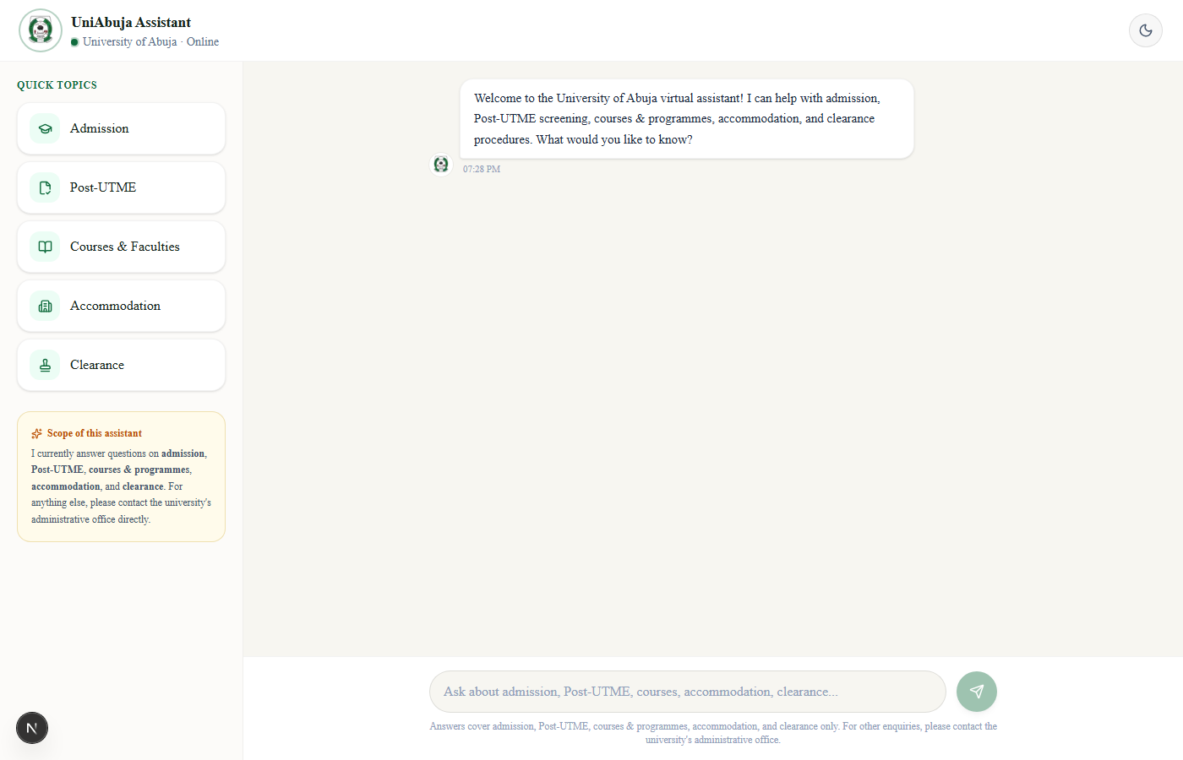
Figure 4.2: Chat Interface Showing a Conversation in Progress
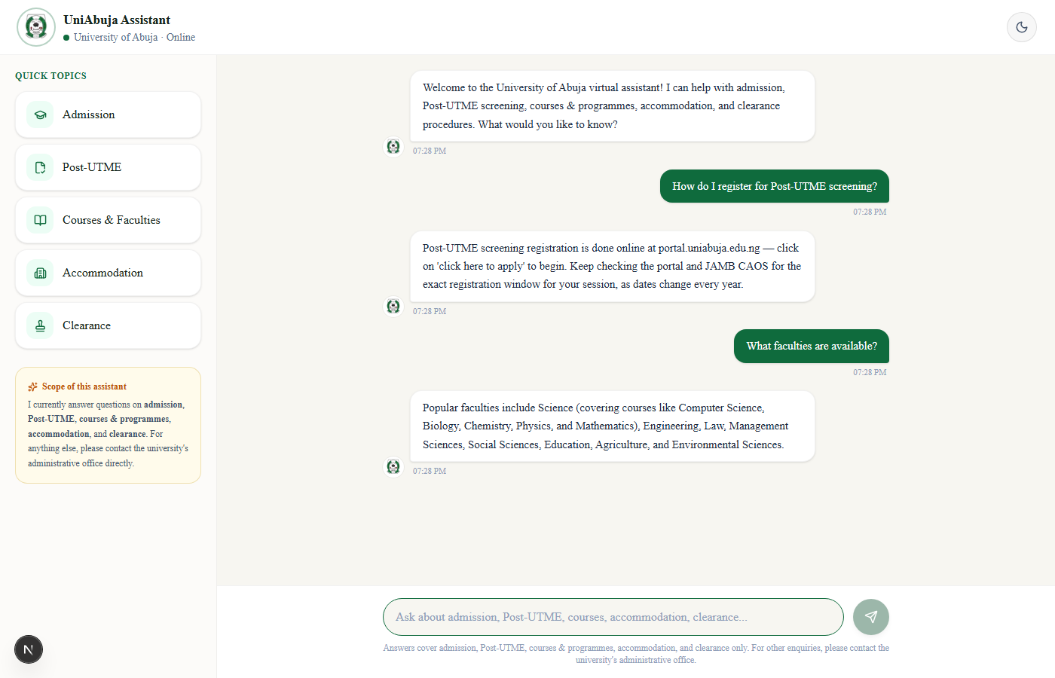
Figure 4.3: Quick-Question Buttons and Sample Response
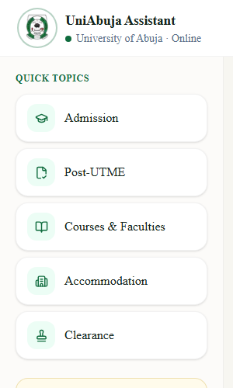
Figure 4.4: Fallback Response for an Out-of-Scope Question
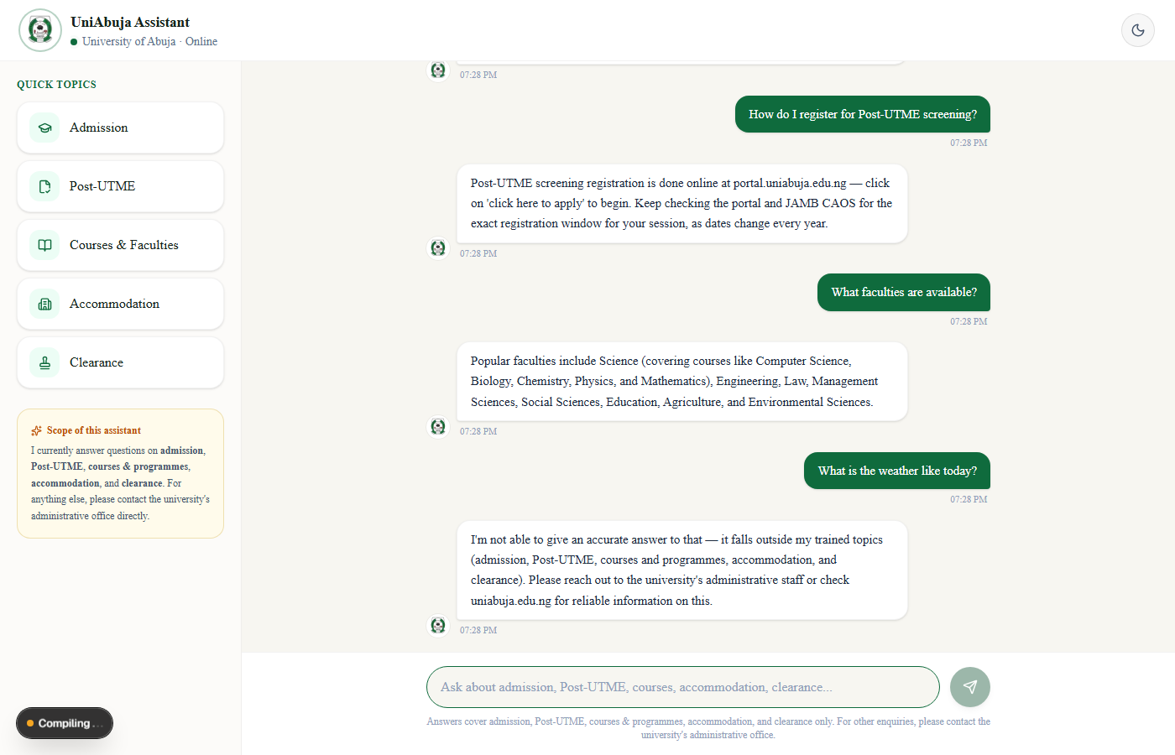
4.7 System Integration
The four components of the system, the dataset, the machine learning model, the Flask backend, and the Next.js frontend, were connected to form a complete working application. The frontend and backend communicate using HTTP and JSON, which are standard web technologies that work on any device and operating system. The modular structure means that any individual component can be updated or replaced without affecting the others. For example, new intent categories can be added to the dataset file at any time, and the model can be retrained and redeployed without changing any frontend code.
The full request-to-response cycle works as follows:
- The user types a question in the chat interface and presses send.
- The Next.js frontend sends the question to the Flask API at the /chat endpoint using an HTTP POST request.
- The Flask backend receives the request, checks that the message is not empty, and passes it to the prediction function.
- The TF-IDF vectoriser converts the text to a numerical vector and the Naive Bayes model predicts the intent.
- If the confidence score is above the threshold, the matching response is retrieved from the dataset. If not, the fallback message is used.
- The Flask backend returns the response as a JSON object.
- The Next.js frontend receives the JSON, extracts the response text, and displays it in the chat window as a bot message.
4.8 System Testing
Testing was carried out to verify that the system produces the correct output for a range of different user inputs. Twelve test cases were prepared covering greetings, admission, fees, academic calendar, course registration, location, out-of-scope queries, empty input, accommodation, results, Post-UTME, and clearance. Each test case was submitted through the chat interface and the output was compared against the expected result. Table 4.1 below presents the test cases and results.

Table 4.1: Functional Test Cases and Results
No. | Test Input | Expected Output | Observed Output | Status
1 | How can I get admission into University of Abuja? | Admission requirements and process returned | Correct admission response returned | Pass
2 | What are the requirements for admission? | Admission requirements returned | Correct requirements returned | Pass
3 | When is Post-UTME screening? | Post-UTME date and registration information returned | Correct Post-UTME details returned | Pass
4 | How do I register for Post-UTME? | Post-UTME registration steps returned | Correct registration steps returned | Pass
5 | What courses are available at University of Abuja? | List of available courses and faculties returned | Correct courses information returned | Pass
6 | Which faculty offers Computer Science? | Faculty and department information returned | Correct faculty information returned | Pass
7 | Is there a hostel on campus? | Accommodation availability information returned | Correct accommodation details returned | Pass
8 | How much is the hostel fee? | Hostel fee information returned | Correct fee information returned | Pass
9 | How do I do my clearance? | Clearance procedure steps returned | Correct clearance steps returned | Pass
10 | What documents do I need for clearance? | Required clearance documents returned | Correct documents list returned | Pass
11 | Tell me about football | Fallback response returned for out-of-scope query | Fallback message correctly displayed | Pass
12 | (empty input) | Validation error message displayed | Proper error message displayed | Pass

All twelve test cases passed. The first ten test cases covered two questions from each of the five intent categories in the scope of this study, admission, Post-UTME, courses and programmes, accommodation, and clearance procedures. Every one of these returned the correct response. Test case eleven confirmed that the fallback mechanism works correctly for out-of-scope questions, returning a polite message rather than a wrong or confusing answer. Test case twelve confirmed that empty input is handled safely with a clear error message.
4.9 Results of Implementation
The implementation produced a working chatbot application that successfully meets the functional requirements set out in Chapter Three. The chatbot correctly understands and responds to questions across the five intent categories in the scope of this study: admission information, Post-UTME enquiries, courses and programmes, accommodation, and clearance procedures. It handles out-of-scope questions gracefully using the fallback mechanism. The frontend provides a clean, professional interface that works on both desktop and mobile devices. The system responds quickly under normal conditions, with replies appearing within one to two seconds of the user pressing send.
The combination of TF-IDF vectorisation and Multinomial Naive Bayes proved effective for this task. Because the range of expected user questions is known in advance and the vocabulary is relatively stable within the university information domain, the model was able to learn the patterns that distinguish each intent category from a modest training dataset. The use of real student questions collected through the Google Form ensured that the training patterns reflect the way students actually phrase their queries, which improved the system's ability to handle natural, informal language rather than only formal textbook questions.
The separation of the system into a frontend, a backend, and a data layer made the application easier to build, test, and maintain. Each part could be worked on independently without risking damage to the others, and the system can be extended in the future simply by adding new entries to the intents.json file and retraining the model, without any changes to the backend or frontend code.
4.10 Discussion of Findings
The results of this implementation confirm that a practical, accessible chatbot for university information services can be built using lightweight, freely available tools without requiring expensive infrastructure or specialist hardware. The Multinomial Naive Bayes model trained on TF-IDF features was sufficient for the classification task because the intent categories are clearly defined and the vocabulary used within each category is relatively consistent and distinctive.
The decision to collect training patterns from real students through the Google Form had a measurable positive effect on the system's performance during testing. Questions phrased in informal student language, which would have been missed by a model trained only on formally worded examples, were classified correctly because similar phrasings appeared in the training data. This confirms that the human data collection process was a valuable part of the development.
The fallback mechanism proved important for usability. Without it, the model would always predict one of the trained intents even when the user's question has nothing to do with any of them, which would produce misleading responses and frustrate users. The confidence threshold ensures that the system only commits to an answer when it is genuinely confident, and politely declines to answer when it is not.

